SUMMARY OF QUALIFICATIONS

Dedicated and enthusiastic information technology professional with significant knowledge and experience in undertaking test analysis, programming, and related highly technical duties for clients to improve system stability, functionality, and efficiency. Quick to become familiar with the latest technologies and industry developments, while demonstrating a logical and analytical approach to solving complex problems and issues. Possesses excellent interpersonal and communication skills and the ability to develop and maintain positive internal and external relationships. Enjoys being part of a successful and productive team and thrives in highly pressurised and challenging work environments.

Core Competencies/Areas of Expertise

Selenium • Automated Testing • Manual Testing • JAVA • Tracking • Logging and Reporting • Quality Assurance • Test Case Development and Execution • ISTQB • Communication

Technical Expertise: SQL, JavaScript, XML, PHP, CSS, HTML, GIT

SKILLS PROFILE

Knowledge of test analysis, programming, and related technical areas
- Possesses a Master of Information Technology degree from Dharmsinh Desai University and a Bachelor of Information Technology degree from Ganpat University, both in India.
- Worked as a Test Automation Engineer with 9 Series Private Ltd in India from 2016 to 2017 and is an ISTQB Certified Tester.
- Competent in a wide variety of technical tasks, including handling elements in Selenium WebDriver, Object-Oriented Programming in Java and PHP and SOAP concepts, manual testing, and ISO 9001 and CMMI requirements.

Technical support and customer service
- Experienced in resolving highly technical issues facing clients, including MySQL queries and Java programming, as well as defect and bug recovery.
- Handles clients with decorum and respect, and is currently a Community Support Worker in Auckland, New Zealand.

Communication and teamwork
- Works well with both staff and external technical personnel to deliver value to clients.
- Communicated regularly with the Lead Test Analyst and other staff members on the team, and often with the client as well, while working in the previous position of Test Analyst in India; accustomed to regular oral and written communication over complex issues that arise.

RELEVANT PROFESSIONAL EXPERIENCE

TOMAHAWK, NZ • March 2019 – Present
Junior Web Developer
- Developing websites and Push on Production level.
- Hands on practice with HTML, SCSS, CSS, Java Script and PHP with SQL, MYSQL
- Technology: Visual studio code, FileZilla, Workbench.
- Coordinated testing resources and shared data using GIT.
- Developer side testing which includes code review, bug fixing and manual testing.
Key Achievements:
- Teamwork, Performance enhancement

9 SERIES PRIVATE LTD, India • 2016 – 2017
Test Automation Engineer
- Designed test cases from requirements documents and functional specifications.
- Estimated, planned, and conducted feature, regression, load, and performance testing on each software iteration.
- Undertook automation testing in Selenium and Java.
- Gathered requirements from Test Leader and analysed them for testing perspective.
- Wrote and executed SQL queries to perform the back-end testing in the driver information database such as creating and maintaining tables and schemas.
- Collaborated with a team, Developed and executed test scripts to identify, and document software defects and finding their causes.

Key Achievements:
- Successfully ran both manual and automated tests.
- Executed tasks to the satisfaction of clients.

ADDITIONAL EMPLOYMENT
SPECTRUM CARE, Auckland, New Zealand • 2018 – Present
Community Support Worker
- Engages clients in community access activities and encourages them to rebuild their self-confidence.
- Provides active support in physical activities and supports clients to achieve their personal goals.
- Assists clients with various personal tasks, including budgeting and shopping.

EDUCATION AND PROFESSIONAL DEVELOPMENT

DHARMSINH DESAI UNIVERSITY, India
Master of Information Technology
- Including Software Design and Engineering

GANPAT UNIVERSITY, India
Bachelor of Information Technology
- Including units in Communication Skills, Computer System Organisation, Internet Programming, Object-Oriented Programming, DBMS-1, Operating Systems, Data Structure, DBMS-2, JAVA, Advanced JAVA, Object-Oriented Analysis and Design, and Software Engineering

COURSES/ CERTIFICATIONS/ LICENSES

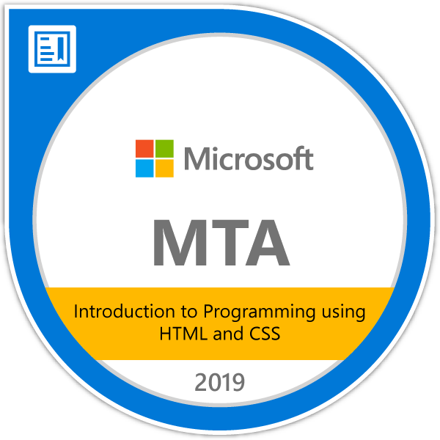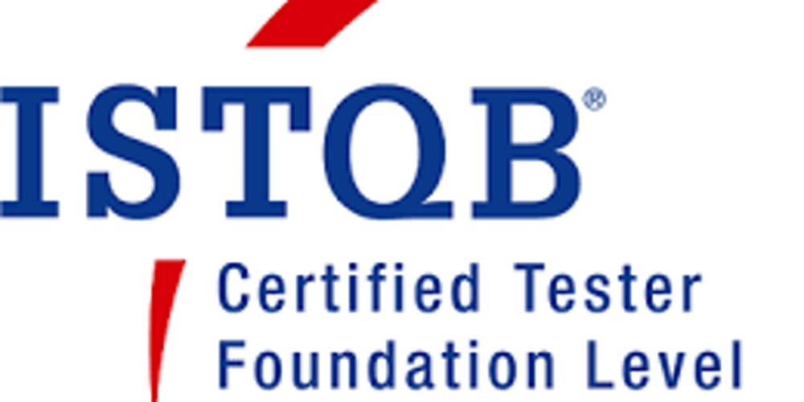

ADDITIONAL INFORMATION
Professional Membership:
Tomahawk, 9 Series

Languages Spoken:
English, Gujarati, and Hindi
Interests:
Travelling and photography

REFERENCES

Nikita Khatri
Team Lead, 9 Series
Gujrat, India
Telephone: +91 94298 92669

Rodulfo Taer
Team Leader, Spectrum Care
Auckland, New Zealand
Telephone: 022 103 5535

